**WOLLO UNIVERSITY**

**KOMBOLCHA INISTITUTE OF TECHNOLOGY **

**LEATHER ENGINEERING DEPARTMENT**

**INTERNSHIP PROJECT**

**Improving the inventory management and work handling of design section to increase productivity in Ramsey Shoe Company**

**BY**

**NATNAEL MULUGETA**

**WOUR/0981/09**

**HOSTING COMPANY: - RAMSE SHOE FACTORY**

**Project Advisor – Mr. Abraham**

2013 E.C

Acknowledgment

I would like to thank first and for most God Almighty, for his protection, blessings and provision that have never been set apart from me since child hood to this day. And I also would like to thank and recognize every individual that have been by my side and helped me to reach this time of my life including my parents, friends, teachers and colleagues. Finally, this research would not be as best as it is now without the consistent supervision and advisory of our company production manager Mr. Habtamu Asrat and the planning Manager Mr. Abraham Tadesse and the final supervision of our advisor from campus Mr. Abraham. May God bless you abundantly and keep you safe, thank you for what you all done.

Approval

I Natnael Mulugeta fourth year leather engineering (footwear stream) student, have undertaken my Internship experience in Ramsay shoe factory from a period of …………… under the guidance of Mr.Abraham (Academic Advisor) and Mr. Habtamu Asrat and Mr.Abrham Tadddese (company advisors).

I assure that this project is original and has not been submitted to the Institute by any other students before and compiled according to the internship report writing guideline given by the department.

Abraham Alemu ……………. ………………

Academic Advisor Signature Date

Natnael Mulugeta ……………. ……………….

Name of student signature Date

Habtamu Asrat ……………. ………………. Company Advisor signature Date

Seal of the Company___________________________________________

Abstract

Stores (Inventories) are one of the main sections of not only footwear firms but every manufacturing and production industry. Raw materials have to be initially stored first for planned and known output. The design section as well is a place where products are developed and unending creativity and innovation is put to a visible work (shoe in our case), which affects the marketing and sales of the company (clients and buyers looks for a better and fashionable product).

Improving these two sections by any means is not a choice but a mandatory move to take as a company who needs to be up-to-date with the time and keep satisfying its clients in order to increase profitability.

Inventory management software’s are well known for achieving this goal by easing the work done by involving storage of the firm, but due to their development (the fact that they are not made by our countries and environment scope, it’s hard to implement and get the uses out of them).

That’s why I came up with an idea of improving the in and out access of store and the entire order and receive process of various sections in the company for reduction of the time wasted by this action. The other aim of this project is to completely change and reorganize the design room and its furniture’s for better handling of prototypes made in the section and create a safe and sound design room which will help the designer’s creativity and innovativeness.

Keywords: IMS, Inbound access, Outbound access

1. Chapter-1

# Background of the company

Ramsay shoe factory was established in 1993 and is estimated to have an average annual turnover and asset value of 2 million. Ramsay is mainly engaged in the production of men’s shoes. it has about 500 employees. Ramsay has a modern organizational structure and every role undertaken by qualified professionals in their respective areas. Ramsay produces both men’s and women’s shoe, with men’s shoes accounting for more than 85% of output. The firm has a production capacity of 2000 pairs per day.

Ramsay has its own outlets in various locations and the majority of its sales are made on cash basis. it also delivers products on a consignment basis to customers with whom it has an established relationship and who have a good credit standing.

The firm participates in international trade fairs and uses various government support and promotion program to access international markets. Most customers however contact the firm directly both for small and bulk supply. Ramsay has been exporting its exporting its products since 2005/06 and presently 90% of the total revenue comes from export sales.

## Vision

Becoming one of the leading shoe manufacturing in Africa by utilizing Ethiopia’s huge capacities and resources in the sector of shoe and other leather products.

## Mission

Providing quality leather products to the international market by utilizing latest leather technologies, production and management systems.

## Values

Ramse company values quality and production speed along with safe and good working environment and employee safety.

## Goal and Objective of the company

* The objective of the company is
* Increasing its market share in the global leather and leather products industry focusing on both quality and quantity
* Creating job opportunities
* Utilizing latest machineries and equipment’s
* Improving productivity through updated production through updated production and management systems.

# 1.2 Ramsay shoe Factory Organization structure

Figure 1 Ramsay shoe factory organizational chart

# 1.3 Overall Work or Process Flow of the Company

## 1.3.1 Raw Material Receiving and Ordering Process

Ramsey shoe factory usually uses the following order to receive raw materials from different suppliers of different input materials. As known different kind, color, thickness and quality of leather is the main input but other items like adhesive, ornaments, threads and other accessories are also raw materials for shoe production undertaken at the company.

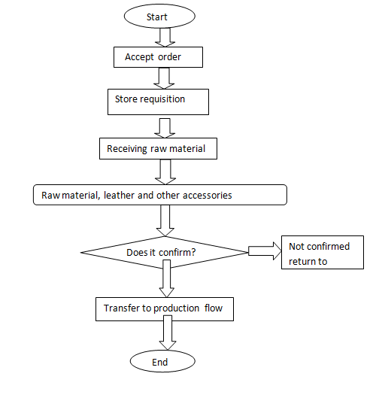

Figure 2 Raw material receiving and selection process

# 1.4 Machinery Infrastructure available in Ramsey Shoe Factory

There are many machineries and tools used in production. And in every section of the production, I observed various modern machineries that are very hard to operate without knowledge of the machine. The data of machineries in every section is listed as follows.

## Machineries in Design room

In the design room of Ramse shoe, there is only one cylindrical stitching machine that the sample maker uses. Other than that, no other machine is used, manual systems are used for design and pattern making.

## Machineries in Preparation Section

Table machines in the preparation section

|  |  |  |  |
| --- | --- | --- | --- |
| No | Name of Machine | Count | Model |
| 1 | Skiving | 2 | ML 801 |
| 2 | Stamping | 1 | CLURL1 |
| 3 | Singer | 2 | TY-3300c |
| 4 | Belt Splitting | 1 | - |
| 5 | Insole Molding | 1 | - |
| 6 | Stamping | 1 | COD0133L80 |

## Machineries in Cutting Section

Table machines in cutting section

|  |  |  |  |  |  |  |  |
| --- | --- | --- | --- | --- | --- | --- | --- |
| **No** | **Name of Machine** | **Count** | **Model** |  |  | **Idle** |  |
| 1 | ATOM spa-Via Morosini | 21 | MF24GEXT25 |  |  | 4 |  |

## Machineries in Stitching Section

Table machines in stitching section

|  |  |  |  |
| --- | --- | --- | --- |
| **No** | **Name of Machine** | **Count** | **Model** |
| 1 | Double Needle M/c | 10 | - |
| 2 | Single Needle M/c | 13 | KDD8810 |
| 3 | Hammering | 2 | MACB4E |
| 4 | Zigzag M/C | 1 | KDD566H |
| 5 | Trimming | 2 | GP8 |
| 6 | Trimming | 1 | GP2 |
| 7 | Double heat and cool sweep back part molding | 1 | CMD68 |
| 8 | Eyeleting | 1 | KN01 |
| 9 | Thermo folding | 2 | - |
| 10 | Skiving/c | 1 | - |
| 11 | Cutting M/c | 1 | - |

## Machineries in Lasting and Finishing Section

Table machines in lasting and finishing sections

|  |  |  |  |  |  |
| --- | --- | --- | --- | --- | --- |
| **No** | **Name of Machine** | **Count** | | | **Model** |
| 1 | Toe Lasting M/C | 2 | CF-737M2 | | |
| 2 | Mulling (Upper conditioning) | 1 | | - | |
| 3 | Back Side Steaming | 1 | | SK-337X | |
| 4 | Seat Lasting | 1 | | CF-727DP | |
| 5 | Heat setting | 2 | | CM-G9WE | |
| 6 | Mock Ironing | 2 | | - | |
| 7 | Hot Air Blowing | 2 | | - | |
| 8 | Pounding & Blowing | 1 | | - | |
| 9 | Roughing | 5 | | - | |
| 10 | Brushing | 1 | | - | |
| 11 | Heat Reactivate | 2 | | - | |
| 12 | Sole Attaching | 3 | | AS100K4t | |
| 13 | Delasting | 1 | | CM-G-850 | |
| 14 | Spray Cab | 1 | | - | |
| 15 | Thermo Pressing | 1 | | YF-10N | |

# 1.5. Product variety and styles with pictures

Ramsay shoe factory produce deferent types of shoe. These all shoe have their models and to produce throughout its life served the local and foreign customer by providing different kind of shoe made by pure leather.

The company produces men, women, baby, safety and moccasin shoes.

**Men’s:** - bades shoes, fashion shoes, fotos shoe, Edward shoes, cat…. etc.

**Women’s: -** M-06, foto 51, foto 9, O-model, etc.

**Baby: -** room 01

**Safety: - Safety** HB, Safety LD and Safety LB

**Moccasin: -**bades, R04, Loren, 6201, etc.

## 1.5.1 Sandals

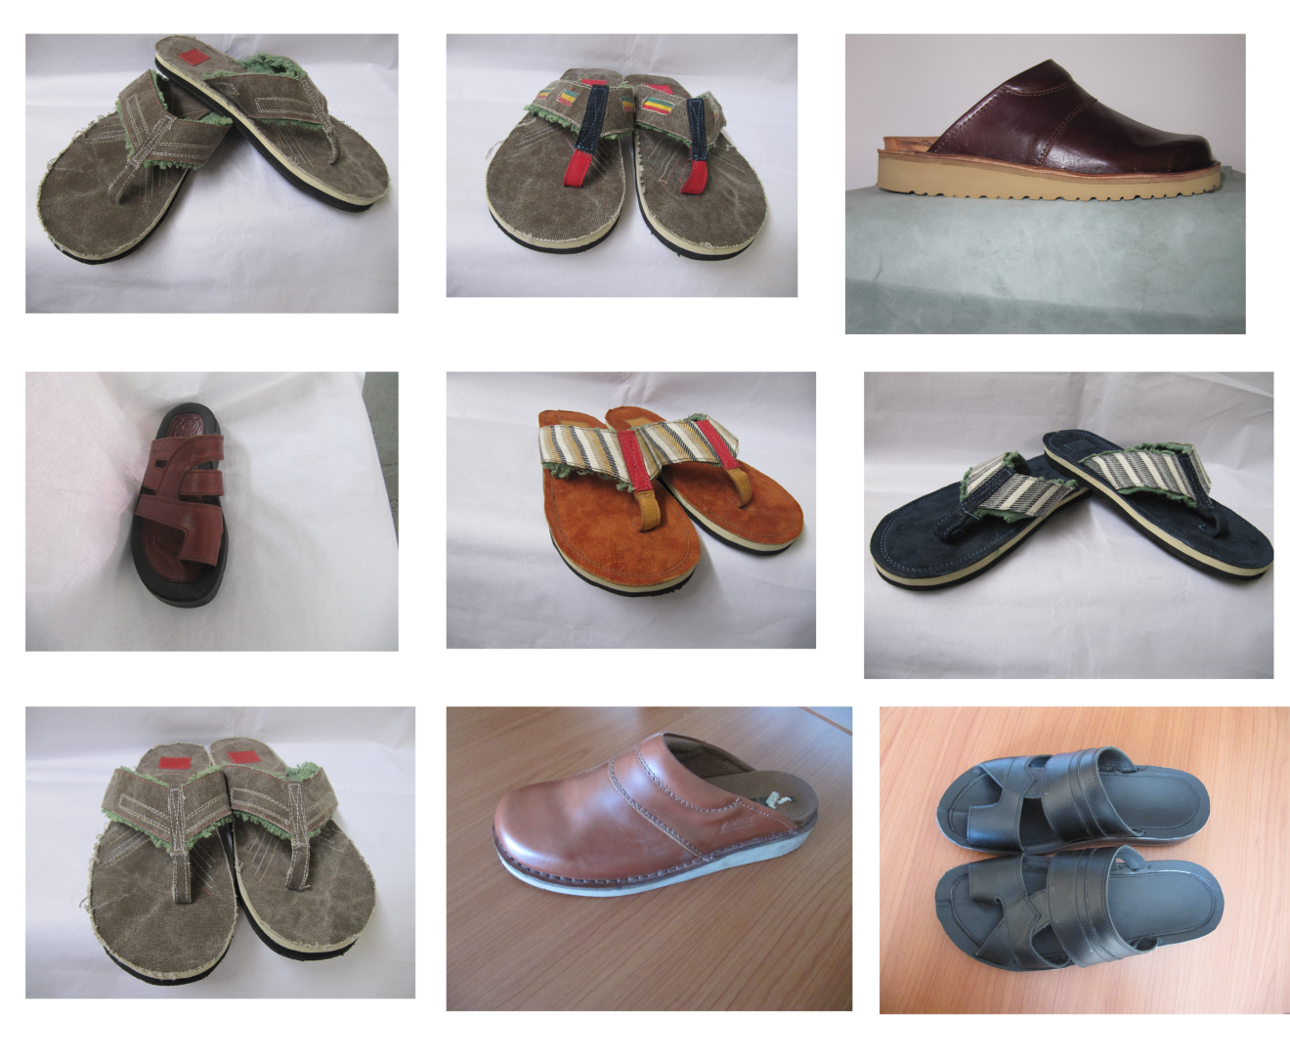

Figure 3 Sandal shoes

## 1.5.2 Women’s shoewomans ramse.png

Figure 4 Women’s shoe by ramse

## 1.5.3 Mans shoe

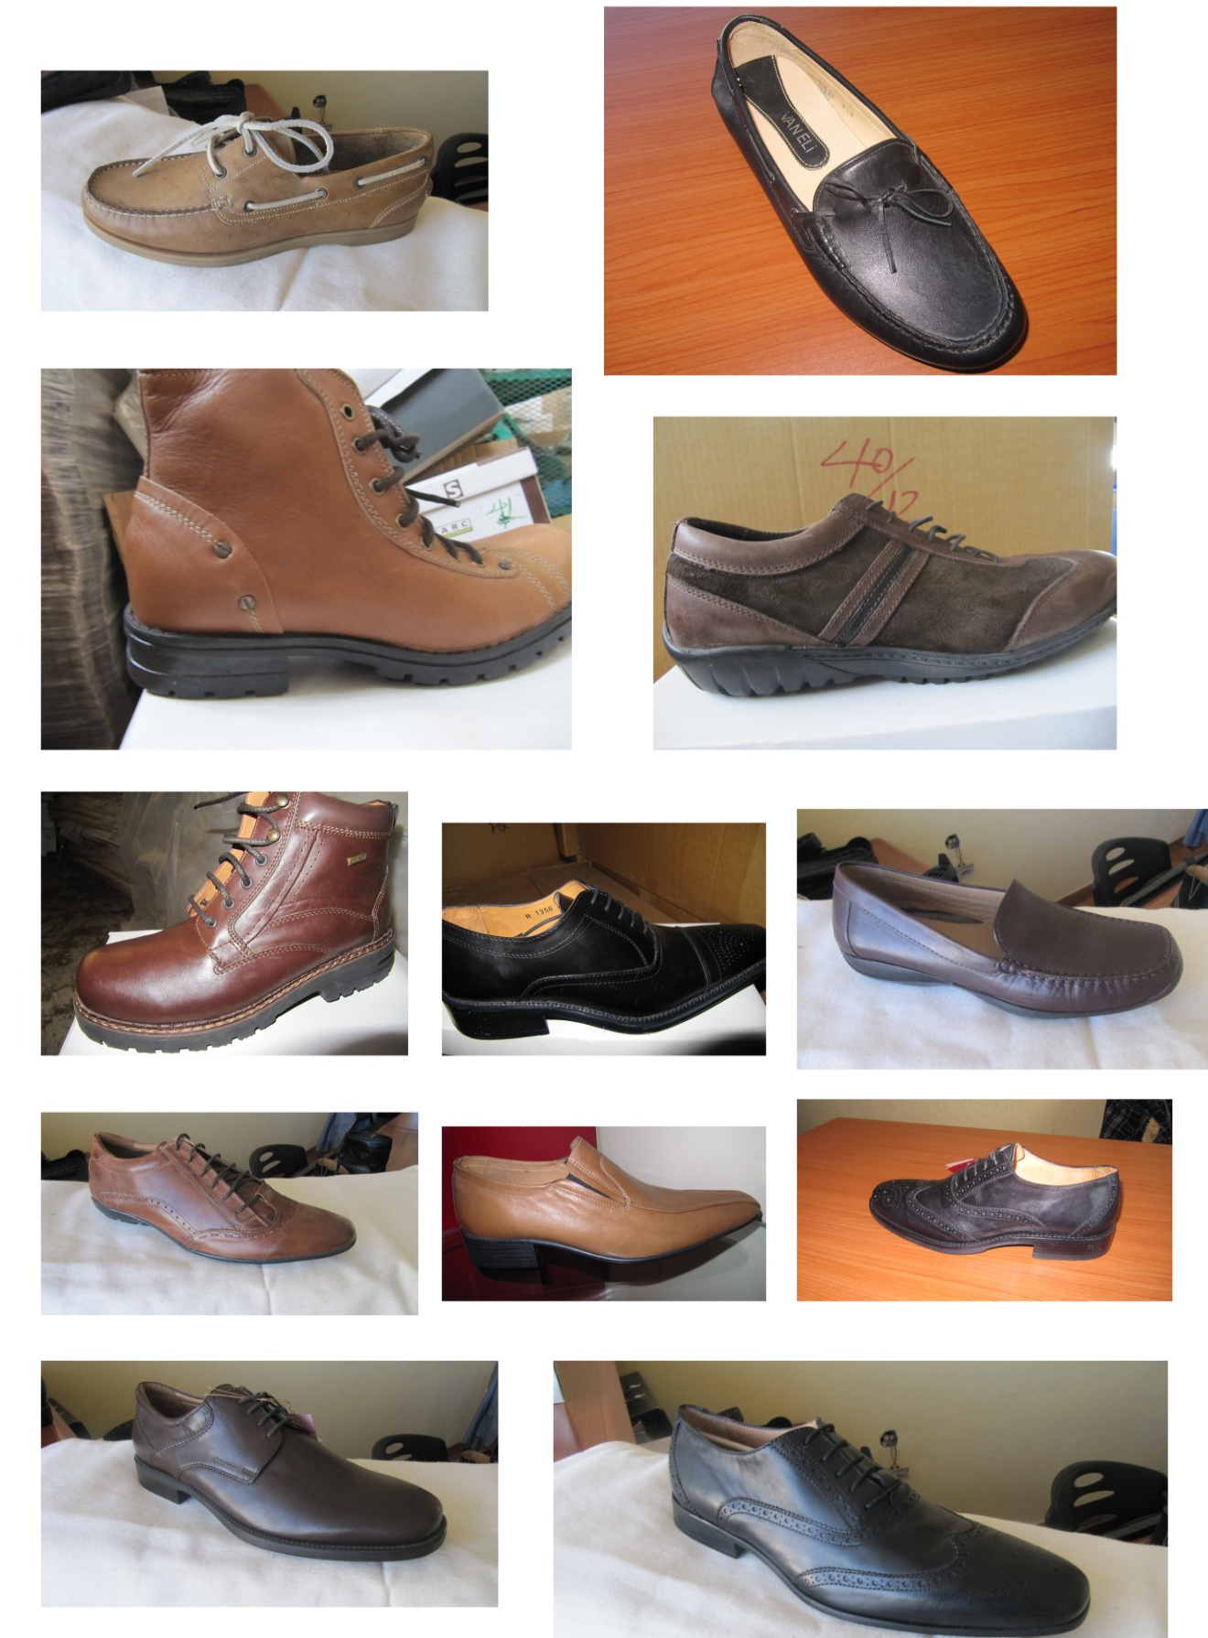

Figure 5 Men’s Shoe

# 1.6. Main suppliers and customers

## 1.6.1 Row materials suppliers

|  |  |
| --- | --- |
| **Raw materials** | **Main suppliers** |
| Leather and lining | Colba tannery, battue tannery, Ethiopian l.t |
| Out sole | Turkey and Italy and its own out sole factory |
| In sole | China and Italy |
| Last | Italy, turkey and from neighbor |
| Shank steel | Local only |
| Threads and adhesives | Italy turkey |
| Packaging materials | Local |
| Reinforcement plaster and foam | Turkey and local |
| Eve sheet and thermoplastic counter | China turkey |
| Shutter and thermoplastic hot melt | Italy and china, local |
| Elastic material and stocks | China, Italy and turkey |

## 1.6.2 Accessories suppliers

Table suppliers of accessories used in shoes of ramse

|  |  |
| --- | --- |
| **Accessory or shoes ornaments** | **Main suppliers** |
| Eyelet | Turkey and local |
| Zipper | Italy and china |
| Buttons | Turkey Italy |
| Insert steel | Local, china turkey |
| Buckle | Turkey |
| Velvet | Turkey |
| Another logo | Turkey and china |

# 1.6.3The main customers of the company

## 1.6.3.1 Local customers

* Police commission
* Banks and insurances
* Abay dame worker
* Other company workers
* Addis Ababa Education Bureau

## 1.6.3.2. Foreign Customers Countries (Export)

* Turkey
* China
* Italy
* Kenya

Other than these customers the company has 13 shops allover Addis Ababa and more upcoming shops to be opened, for local market distribution.

# 1.7. Monthly production plan

Ramse plans every production according to the incoming order by the clients of the company. Mostly the orders fluctuate, they sometime come in a higher number and sometimes fewer.

Generally, the company has a production capacity of 2000 pair shoes per a day (eight working hours). There are various factors that have to be considered to fully achieve the capacity. Some of them are raw materials, full man power, working machines

The table below is estimating the production capacity on monthly basis and generally shows the year’s capacity for planning efficiently.

Table Production Capacity of Ramse

|  |  |  |  |  |
| --- | --- | --- | --- | --- |
| No | Month | Working Days | Max Capacity | Min Capacity |
| 1 | MESKEREM | 24 | *2000=48000 | *800=19,200 |
| 2 | TIKIMIT | 25 | *2000=50000 | *800=20,000 |
| 3 | HIDAR | 26 | *2000=52000 | *800=20,800 |
| 4 | TAHISAS | 25 | *2000=50000 | *800=20,000 |
| 5 | TIRR | 25 | *2000=50000 | *800=20,000 |
| 6 | YEKATIT | 25 | *2000=50000 | *800=20,000 |
| 7 | MEGABIT | 26 | *2000=52000 | *800=20,800 |
| 8 | MIAZIA | 22 | *2000=44000 | *800=17,600 |
| 9 | GINBOT | 24 | *2000=48000 | *800=19,200 |
| 10 | SENE | 26 | *2000=52000 | *800=20,800 |
| 11 | HAMLE | 25 | *2000=50000 | *800=20,000 |
| 12 | NEHASE | 25 | *2000=50000 | *800=20,000 |
| 13 | PUAGMEN | 5 | *2000=10000 | *800=4000 |

The working day varies as the month changes, according to the Ethiopian calendar the holidays and Sundays of every month are removed out of the working days. In ramse company the operators and the company have an agreement to work for additional twenty minutes every morning and afternoon shift, so that they can work only half day of their Saturday. But we count Saturday as a full working day (eight hours).

# 1.8. Utilities and source of utility

The main utilities that the company uses are power and water, both from the government offices of ELPHA and water and sewage authority. The other factor that can be mentioned as a source of utility is a gas depot that is being used as a source for the three huge generators used as a backup for power.

2. CHAPTER-2

# 2.1 Introduction to the project

## 2.1.1 Background and Justification

Stores are we can say the main functional sections of almost any firm as known, since there will not be any production if there is no store or properly organized inventory. Improving this most important section is no question to be dealt with. From entry to usage raw materials have to be handled properly according to their type, frequency of usage and other factors. Making the entire process digital and the process easy will be very useful.

During the past there has been emerging realization of the important contribution of **inventory management** to supply chain performance**. It is the general characteristic of practitioners in most industries to improve performance for competitive advantage** (Porter, 1985). Performance can be measured against value, which simply implies meeting customer needs. In assessing the impact of inventory management on supply chain performance, two key components are identified, i.e. doing it more effectively, and doing it more effectively and efficiently.

Effectiveness refers to value maximization whereas; efficiency refers to minimization or elimination of non-value-adding items. It is important to assess the impact of inventory management on supply chain performance. Companies like Ramse and their suppliers have to understand how both can gain competitive advantage through the inventory management. For an efficient and effective inventory management, such organization should be able to determine how much inventory should be held at a particular time, when to reorder, what is the lead time the end user is willing to accept, what inventory model best suits the organization and how can the inventory system be controlled and communicate with the incoming and outgoing requests.

This paper mentions and recommends a way that will be discussed in detail more later, but proofs that upgrading the mechanisms of handling, recording and sorting items will have a visible difference in production speed and maintain fair and smooth communications between staff members and operators as it minimizes physical communications in a way that everyone can stays where they work and request for the items required, so that specific persons can deliver them as they get approved by the specific manager.

Design and product development section of a footwear company is the starting point of any mass production and major section, and needed to give quite a good focus and attention for it. Shoe designers as known are specialized fashion designers that create original shoes. It’s an artistic action and need peace and visual stability of mind to be creative and innovative.

As a designer what you see and hear even smell defines what you will come up with later, its mandatory to make the working environment of the designers very well equipped and interesting, their prototypes also have to be handled and stored in a manner that the safety and display quality is great.

# 2. 2 statement of the problem

Inventory process have impact on production time and productivity which later causes to not deliver at a proposed time. also have lot of impact on the profitability of the firm and its success. Inventory management system and its optimized workflow are depending on the identification of key success factors and right decisions at right moment. The survey approach can bring a light on the variables and these have lot of biased information. Testing of the factors influence on inventory decisions by using scientific methods can help to improve the reliability of the factors taken as key variables in decision making. Hence, the present paper is focused on the dimensions by identification of Factors influencing inventory optimization in ramse shoe company through a structured and unstructured way.

The main issue here is that in order to get a right material at the right time for production in a specified section the line manager faces different peoples and requests in a manual way, then after the right person will again inform for approval and sometimes when reaching the store, the right material might not be available and other paper works are also needed to be finalized. These entire processes have a significant impact on time and tires the person.

The next thing that I observed as problem in ramse company is that it needs the improvement of and data handling of design room. design. In this factory I have observed that there is a major problem in the environment and storage at the design and product development section. The items are not well organized and put everywhere, the design tables are ordinary tables and not comfortable for sketching and design. The look doesn’t create a peace in mind and does not make the designer feel creative and innovative. There is no enclosed shelf with enough light to show the quality of the prototype and every shoe in there are full of dust.

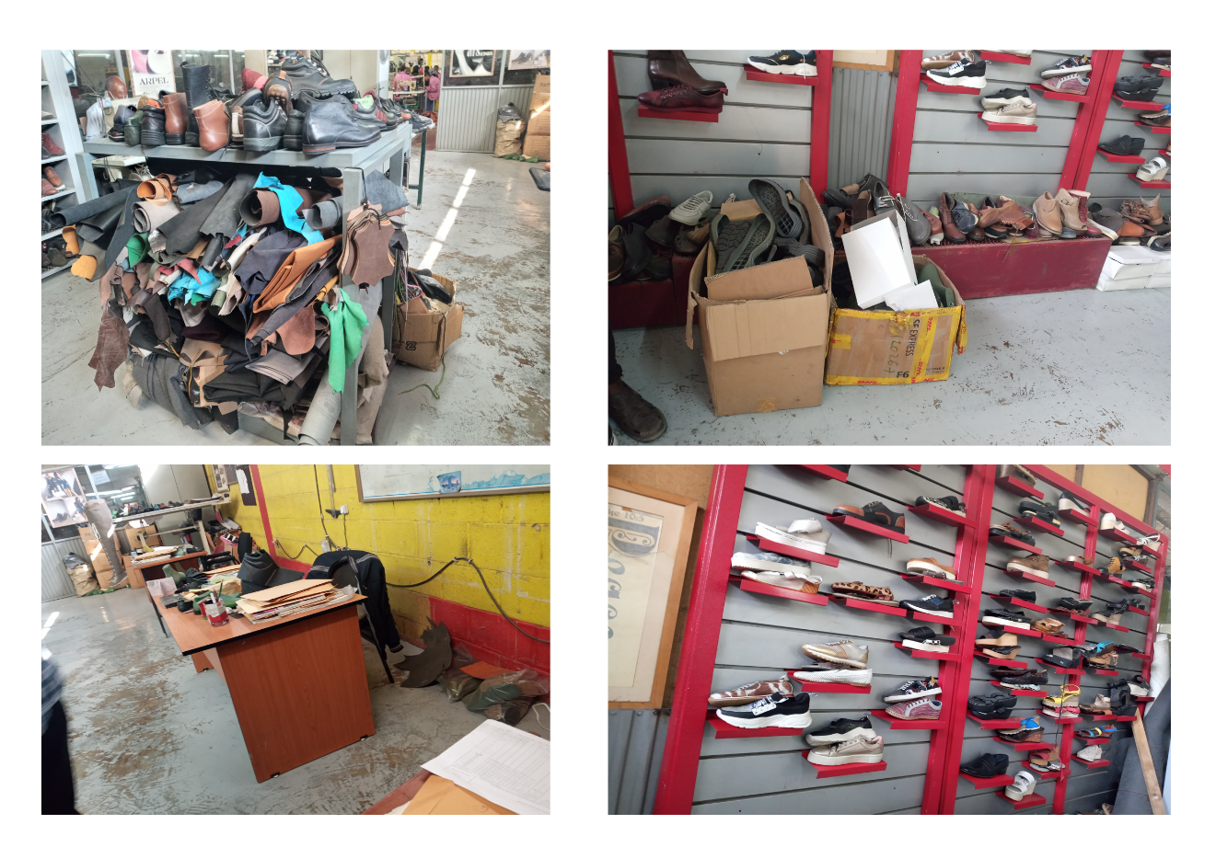

Figure Design room at ramse

## 2.3 Objective of the project

### 2.3.1 General Objective

My study aims to give a solution to the observed problem of longer time in the process of bringing out a raw material in store to the production area by eliminating the entire communication and request approval hierarchy system that the company uses currently.

In the design section perspective making the design room good for improved creativity and innovative thinking, and better storage and display of design prototypes is the general objective

### 2.2.2 Specific Objective

The specific objectives of this project are mentioned as follow

* To make the communications between sections of the firm more smooth
* Reduce paper work and hustle of it on the workers
* Keep the data of items entering and leaving the store room for further studies
* Increase the delivery time of orders so that the company could become more trustworthy and profitable
* Reduce the time of process entry of a raw material
* Eliminate the physical movement of a worker form assigned place of work
* Maintain a good system of data recording and handling so that a potential researcher in the future can use it as a secondary and the person assigned could use it for a final yearly report of the company and auditing usage.
* Improving the look of design room
* Better shelf for improved prototype display and handling
* Computer based design in order to eliminate excessive usage of scotch and papers
* Pattern and other measurement data should be handled in computer-based databases for later uses and as a backup of potential hazards
* Furnishing the design environment for better comfort and later influence the design quality, by environment I mean
  + - Table
    - Chairs
    - Air conditioning
    - Hot and cold drinks mini storage
    - And other apparatus...
* Separating the design section if possible, from the production to reduce the sound of machineries that makes the designers to do not focus on the work
* Changing the windows in order to make the entrance of enough light possible into the design room
* Changing the entire paint of the design section, which is currently blocking day light entry and creates a dizzy feeling.

# 2.3 significance of the project

## 2.3.1 Benefit

#### Improve Storage mechanism

As this project intends to implement the usage of inventory management software implementation the storage mechanism will be significantly change, and every detail including the shelf number of a specific item will be known, which later reduces the time it looks for items in the crowded store of the company.

#### Improve communication between sections

This implementation will improve the communication between the managers and operators of a section as they do not need to physically be gone to an office (I.E production manager’s office) for requesting and store keeper’s office to sign and get approved of the request. For example, let’s say in cutting section a batch of raw material is needed to be cut for later process, currently the cutting line manager have to go physically in to the manager’s office and they have to allow the orders. Not only this but there is proceeding procedures to achieve later in the store.

#### Well Storage and backup of production data

The system this project intended to implement will store every item order and approval data of every item being processed. This will later be used to for research and other purposes like auditing and other stuff.

#### Better design room

Better design room will be achieved after a success full integration of the recommendations in this project. The room will be well equipped and become visually attractive which will increase the visual value of the entire company.

#### Better prototype handling and display

The prototype handling and preview (display of designed shoes) will be completely changed so that any client that see the room will have a good opportunity of deciding to agree with the company for production. They will also be preserved without being exposed to dust and other factors that will reduce the good look and durability of the product.

#### Improved design data handling

The data’s that are needed to be stored for next work like last number, size, the picture of the product and other important data will be stored in a computer-based database which will be intentionally made for the design room.as a backup for hazard and incidents like fire accidents and other natural and manmade disasters.

## 2.3.2 Beneficiary

#### The company

The first stakeholder that benefits highly from this project is the company itself as it completely changes the look of its design room and significantly reduce the time wasted by procedure of storage access as production will increase highly.

#### The Designers

I proposed a complete change of the deign room with numerous added values and apparatuses like coffee and water dispensing machine and paint the walls with visually attractive paintings that initiates for creativity. And the chairs and tables will be transformed into professional design furniture’s that gives comfort and health safety (to work for long hours).

#### The Operators in the company

The hustle that operators were experiencing due to moving place to place and will be reduced and help the to focus only on their work.

#### Our Institute (Wollo University)

We are the first interns to be accepted in ramse company from wollo university, Kombolcha Technology Institute. The company now has a good acceptance for us as a result of the good time we had during the internship season. The institute for sure will be accepted to send the next batch and after.

# 2.5 scope of the project

The scope of this project is to increase productivity and profitability of the company by reducing and possibly eliminating the observed problems in the store and design sections of the factory.

On the store sorting recording and putting the items in database for later ease of usage (inbound and outbound) access. And while ordering a raw input time is reduced as the software-based solution does not need physical occurrence of the operator or manager in need.

And in terms of design and product development section starting from the visual look this project intends to improve every minor factor that is blocking the designers from being innovative and come up with new designs every time.

The prototypes are not even put in a proper manner, improvement of the shelf design and addition of other stuffs like light to enhance the look is in the scope of this project.

# 2.6. limitation of the project

The major limitation of this project is I believe that it’s not tested by implementation of the recommended systems, which makes it harder to measure the accuracy and numerical gain and values gained. Only closer assumptions were made.

The other thing is that while collecting data the company was wide and some of the staff members didn’t recognize that I was an intern and refused to give some data’s. The company itself was not willing to give or allow us to take some pictures, but later agreed to take some.

The fact that such researches were not made makes it hard to find secondary data’s and most part of the project are made by observation and primary data collection methods.

# 3.Literature Review

The word inventory doesn't have the same meaning in the USA and in the UK. In American English and in a business accounting context, the word inventory is commonly used to describe the goods and materials that a business holds for the ultimate purpose of resale. In American English, the word stock is commonly used to describe the capital invested in a business, while in British English, the sentence stock shared is used in the same context. In the rest of the English-speaking world stock is more commonly used, although the word inventory is recognized as a synonym. In British English, the word inventory is more commonly thought of as a list compiled for some formal purpose, such as the details of an estate going to probate, or the contents of a house let furnished. In both British and American English, stock is the collective noun for one hundred shares as shares were usually traded in stocks on Stock Exchanges. For this reason, the word stock is used by both American and British English in the term Stock Exchange. Inventories are materials stored, waiting for processing, or experiencing processing. They are ubiquitous throughout all sectors of the economy.

Observation of almost any company balance sheet, for example, reveals that significant portion of its assets comprises inventories of raw materials, components and subassemblies within the production process, and finished goods. Most managers don't like inventories because they are like money placed in a drawer, assets tied up in investments that are not producing any return and, in fact, incurring a borrowing cost. They also incur costs for the care of the stored material and are subject to spoilage and obsolescence. In the last two decades there have been a spate of programs developed by industry, all aimed at reducing inventory levels and increasing efficiency on the shop floor. Some of the most popular are conwip, kanban, just-intime manufacturing, lean manufacturing, and flexible manufacturing. Nevertheless, in spite of the bad features associated with inventories, they do have positive

purposes. Raw material inventories provide a stable source of input required for production. A large inventory requires fewer replenishments and may reduce ordering costs because of economies of scale. In- process inventories reduce the impacts of the variability of the production rates in a plant and protect against failures in the processes. Final goods inventories provide for better customer service.

The variety and easy availability of the product is an important marketing consideration. there are other kinds of inventories, including spare parts inventories for maintenance and excess capacity built into facilities to take advantage of the economies of scale of construction. Because of their practical and economic importance, the subject of inventory control is a major consideration in many situations. Questions must be constantly answered as to when and how much raw material should be ordered, when a production order should be released to the plant, what level of safety stock should be maintained at a retail outlet, or how in-process inventory is to be maintained in a production process. These questions are amenable to quantitative analysis with the help of inventory theory.

## 3.1 INVENTORY MANAGEMENT

[Inventory management software](https://www.mrpeasy.com/inventory-software-manufacturing/) is an integrated management system that helps companies manage and plan their manufacturing and production activities. This is done by making use of various methods to automate and control inventory. The software removes the human element from inventory management, and as such, dramatically improves efficiency and all but eliminates errors.

In any business or organization all functions are interlinked and connected to each other and are often overlapping. Some key aspects like supply chain management, logistics and inventory from the backbone of the business delivery function. Therefore, these functions are extremely important to marketing managers as well as finance controllers.

Inventory management is a very important function that determines the health of the supply chain as well as the impacts the financial health of the balance sheet. Every organization constantly strives to maintain optimum inventory to be able to meet its requirements and avoid over or under inventory that can impact the financial figures.

Inventory is always dynamic. Inventory management requires constant and careful evaluation of external and internal factors and control through planning and review. Most of the organizations have a separate department or job function called inventory planners who continuously monitor, control and review inventory and interface with production, procurement and finance departments.

## 3.2 THE REASONS FOR KEEPING STOCK

There are three basic reasons for keeping and inventory:

**Time** - The time lags present in the supply chain, from supplier to user at every stage, enquires that you maintain certain amounts of inventory to use in this "lead time”.

**Uncertainty** - Inventories are maintained as buffers to meet uncertainties in demand, supply and movements of goods.

**Economies of scale** - Ideal condition of "one unit at a time at a place where a user needs it, when he needs it " principle tends to incur lots of costs in terms of logistics. So bulk buying, movement and storing brings in economies of scale, thus inventory.

## 3.3 Why inventory management software

In the age of automation, it is critical to maintaining a competitive edge. One way to do this is to automate inventory control. There are various options available that can manage the following:

* Order Management – Sales, purchasing, and invoicing can all be controlled by the system. This functionality is even more powerful when integrated with accounting software.
* Ordering – With an automated system it is possible to automatically order manufacturing inventory well in advance of the firm or anticipated orders.
* Barcode Scanning – Inventory can be tracked around the workshop by manually scanning barcodes.
* Up to date product data – Any changes to products can be easily updated to the entire system ensuring that there is no time and money wastage.

## 3.4 Advantages of manufacturing inventory management

### 1. Save money

At the core of any company, there is one simple goal; and that is to make money. Due to the highly competitive nature of manufacturing, it is difficult to deviate far from your competitors’ price point, and as such, one of the ways to remain profitable is to increase productivity, reduce wastage and improve efficiency.

It is very difficult to maintain an organic inventory that reacts immediately to changes. Therefore, attempts at doing this manually often result in various wasteful practices such as purchasing excess material for a project. Holding excess inventory results in carrying costs, and if the material cannot be used on other projects it is an outright loss.

Another way in which manufacturing inventory management software saves money is by empowering employees to make better use of their time, therefore less time is wasted on low-value labor.

### 2. Save time

In today’s manufacturing environment, time is an increasingly rare commodity. Deadlines are perpetually on the limit of feasibility due to the highly competitive nature of the industry. There are many factors that influence the timeframe of a manufacturing project. For example, if you have a large order, then the procurement of materials becomes critical and even the smallest delay can have a domino effect that jeopardizes the entire project.

Manufacturing inventory management software can keep track of exactly how much material is needed for every product, and can ensure that there is sufficient stock available based on projected sales. Furthermore, many of the more labor-intensive processes such as manually counting and controlling stock can be eliminated. Your staff can, therefore, be trained on more complex tasks that can result in higher levels of productivity and job satisfaction.

### 3. Data

Software systems can keep track of data and display trends that won’t be apparent if systems are monitored manually. Data science is a fast-growing field that can benefit any industry where large amounts of data can be generated. Some of the more obvious insights are as follows:

* Sales Tracking – The ebb and flow of sales can be tracked in real-time. By doing this, the best-selling products can be determined, and strategic decisions can be made on which products to cut from the line, and which can benefit from increased attention.
* Wastage Tracking – Wastage can be easily tracked. If a certain product is showing high percentages of waste, management can step in to optimize the process.
* Tool life – The life of your tools can be monitored so that replacements can be ordered before a failure occurs, this means that there will be minimal production downtime.

### 4. Traceability

The entire life cycle of the product can be monitored in real-time all the way from raw materials through to manufacturing, and finally completed products. This is important for proper quality control and certification.

Another advantage of this high level of traceability is to reduce theft within your workshop. If a part or product leaves its designated area, an alert can be raised immediately.

### 5. Integration with other departments

Manufacturing inventory management can be a part of a more complex ERP (Enterprise Resource Planning) systems. This creates an environment where the different business units of a company such as manufacturing, accounting and management can all communicate with each other in real-time, and decisions can be made based on accurate up to date information. If these systems are actively used by employees and managers, it can truly be a powerful tool.

### 6. Customer satisfaction

Inventory management software has the added advantage of improving customer relations. This is due to various factors, some of which are listed below:

* On-time delivery – Nothing can sour a relationship faster than late delivery. If a salesperson sells a product based on outdated inventory data, this can result in cascaded delays.
* Quality products – If a product does not meet quality standards it can be flagged on the system and it can be barred from being accidentally shipped out to the customer.
* Progress Tracking – The act of automatically tracking progress means that it’s a simple exercise to share the progress of their product. This level of transparency instills confidence in your products and processes and will improve the chances of having repeat clients.

### 7. Production rates

[Lean manufacturing](https://manufacturing-software-blog.mrpeasy.com/lean-manufacturing/) principles go hand in hand with inventory management software. Lean manufacturing is basically the process of optimizing manufacturing in such a way as to increase productivity. More efficient control of the flow pf parts around the workshop is a very effective way of trimming off wastage from individual processes.

Inventory management software results in an organized warehouse.

An example of how this is typically implemented is by placing all the components and materials used by the best-selling products within easy reach, to further improve on efficiency. This may not seem like a big change but over the lifespan of a production run, a few minutes per product can translate to a significant overall improvement in production rates.

## 3.5 Literature gap

This project is made on the currently existing issues of ramse company and there is a gap between the general idea of inventory management systems. The final propose solution in this project highly worked on improving and digitalizing the internal communications and approval hierarchy in the company internally.

Particularly time is saved on the process of communication between sections. i.e from stitching section the line supervisor can receive from cutting room by applying on the system without going to the room. This way time is saved, data is recorded and all other benefits are gained.

# 4.Methodology

## 4.1. Introduction

While studying and data collection for this project I have used various data collections mechanisms such as observation, interviews and secondary data collection.

### Primary data collection

Observation was the major mechanism that helped me to identify problems and to record the time it takes for the movement of workers and operators to bring necessary raw materials for production.

### secondary data collections

I have used various secondary data’s that are found in the company other than observation and informal meetings with the section managers, operators and store keepers.

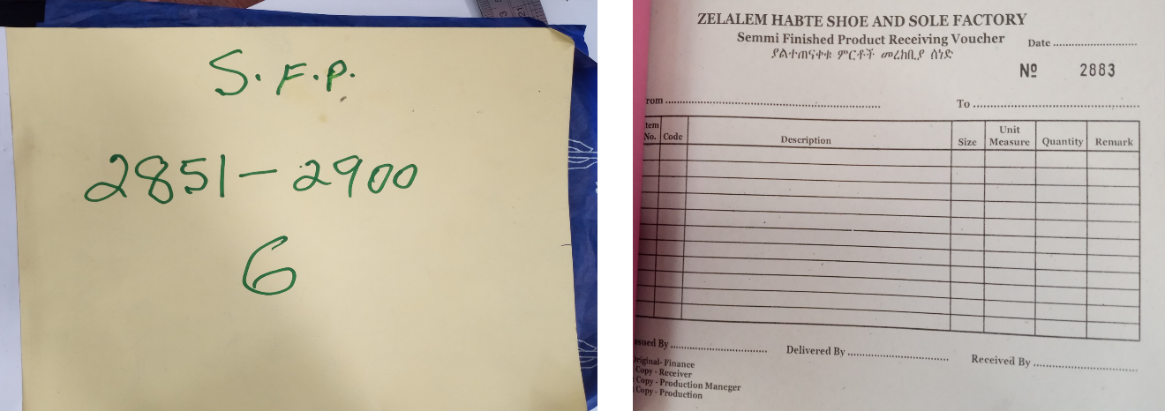

Figure Product receiving voucher

## 4.2. Material

I have used the stop watch app on my smart phone to record the time of the problem and come to an average assumption

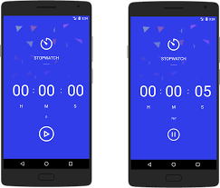

Figure Stopwatch App on a smart device

# 5. Result and discussion

## 5.1. Interpretation and discussion of data

According to the data collected by observation and interviewing of the operators and managers in ramse company I have realized that the time of production is significantly harmed or reduced by the overall process of production in a day. This is happening due to the time it takes to register document the request manually by the store keeper and the time that’s wasted by communication between the manager who gives the authority to access items in store for the workers.

I have also come to a conclusion that huge amount of data is not properly stored for future uses like auditing and production capacity study and other researches. This is harming the company very highly a new assumptions and studies have to be done every time required. It also hard to manage who did what every time, as there are number of operators and workers in such a huge firm.

### 5.1.1 interpretation of time lost

In ramse shoe factory the workers work for eight hours daily in the working days (Monday - Saturday). 2:00 LT is the entry time and 6:10 LT is the lunch break time. Lunch time is allowed only for an hour so that 7:10 is entry time for afternoon work. Finally, a worker is out at 11:10 which will be eight hours a day.

Out of this time as I recorded with stopwatch an operator needs 10 minutes and 30 seconds of time to analyze and talk to the super visor about it. an operator then goes to the planner or production managers to get permission to take from store which takes approximately 20minuites.and the rest of the process takes approximately about 20 – 25 minutes which in total becomes 50:30 – 55:30 minutes. This is almost an hour a day and out of eight working days one days is wasted by this process.

When collected this time becomes very high number of times without a work, which harms the company in both financially and client dissatisfaction. The fatigue of working operators and managers is also mentioned as a factor.

## 5.2. Solution development

### A. The solution for inventory and communication problem

The solution for the problem observed that I have proposed is that the company have to use a software-based inventory communication and raw material input output system. Among those I recommend the following software which was build and designed for exactly the purpose of flexibility and maintaining the difference between firms.

Two years back I was a part of a summer code camp that helps institutions to get modernized. And I worked on this solution which is a flexible store management system which establishes a clear hierarchy communication. By deploying this system without the need to buy much items (only using the existing computers), the company can have an increased production time and reduced hustle in searching raw materials at store.

Additionally, it can increase the accountability of store engaged person, since every action is recorded on the database. Then the data can be used for future use of auditing and research.

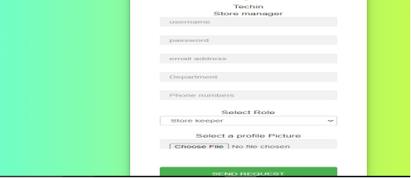

Figure registry for the software (web application)

A new staff member who is recruited as new operator or store keeper or an administrator of system can ask for an account to use the system and if approved, he/she can access and do the task according to the role.

The system automatically validates for more security or for protection of potential threat trials like cross site request forgery and SQL injection. Only right amount of character has to be provided for a successful request of account.

Other main feature in this section is that a person has to carefully select the department because every cycle and approval goes directly to the supervisor assigned for that section. If the wrong value is added the entire process will not be successful. And an account deletion will occur as a result.

### 5.2.1 System Admin Account

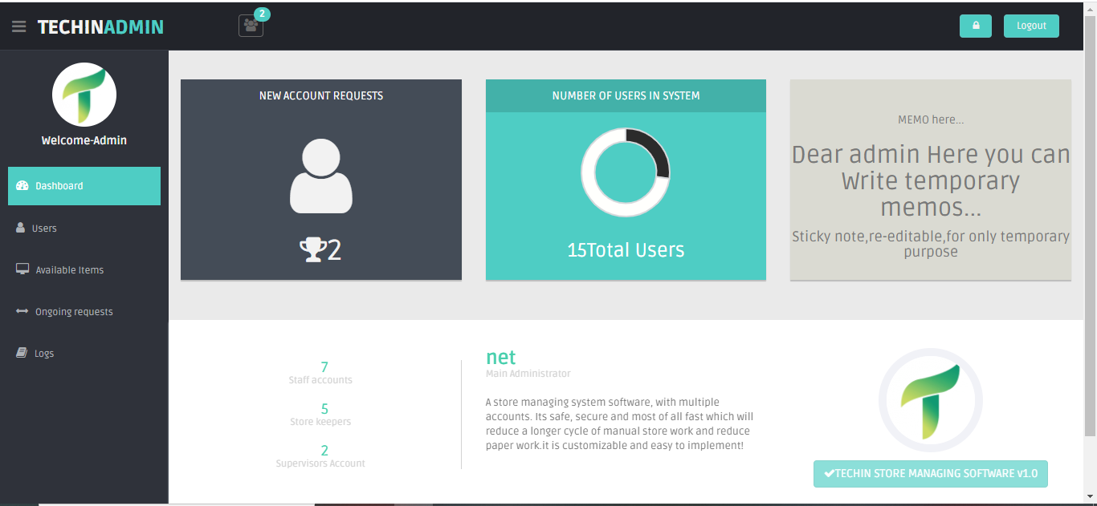

Figure dashboard for admin

The admin can then log to the account and gets a good descriptive dashboard to track follow and interact with everything that goes through the companies store management system regarding accounts and other issues.

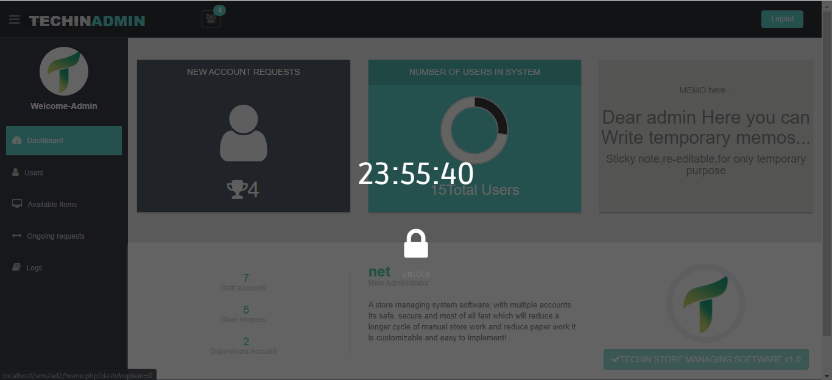

Figure lock feature of admin

Keeping in mind that the admin will have a hustle managing the user input output I have designed a lock feature so that he/she would not login and logout time to time. It has also a time counter for a better user experience.

Up next will be the user management in the admin privilege. It is the main feature I can say. The admin here can allow and discard the request of staff members and supervisors by confirming the appropriate button click.

If approved or declined a request it’s possible to restore the initial status under one condition. The request does not have to be permanently deleted. This feature is designed for future use of account sustention temporarily.

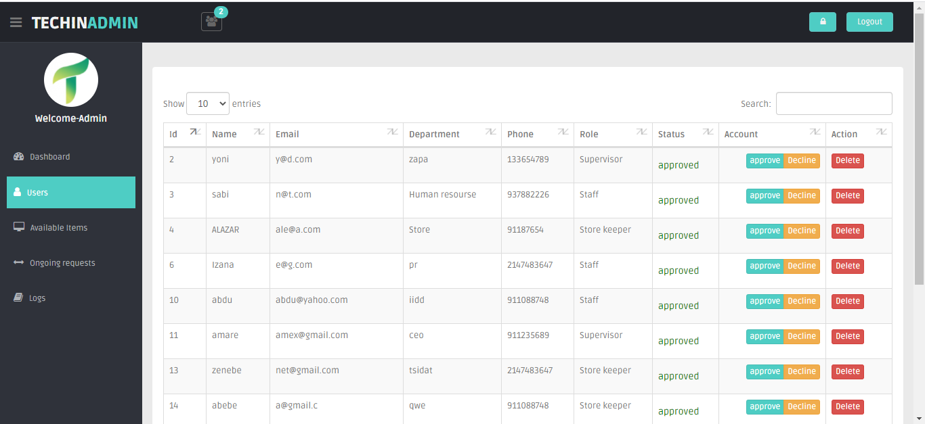

Figure user management of the system

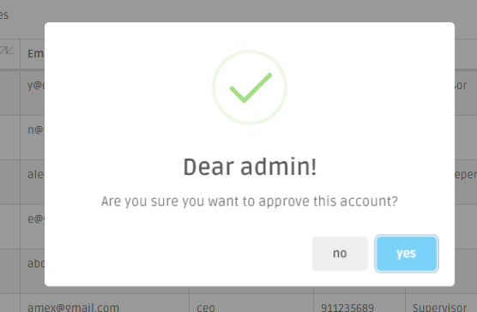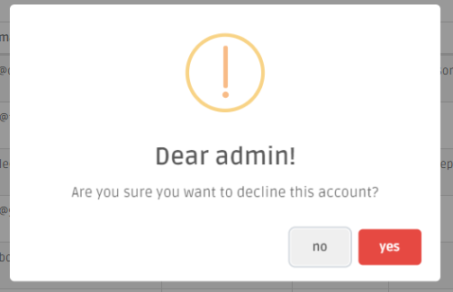

Figure confirmation for decline and approval

The other main feature in the admins features is the session controlling feature. Session is something that records and tracks the activity held in the system. So, the system I made controls and oversees the actions of every operator and staff members in the company.

Here every thing is recorded and able to know who is online currently and who uses the system at a specific time and along with the logout time.

This highly helps to track the usage and in case a failure or an attack occurs it makes it much easier for forensics and analytics of the system usage. While using such software a security issue is some thing bold to be conscious about and watch every move and actions that being encountered with the software. This features presence reduces the potential happenings of a disaster that are caused by intruders and hacker’s action.

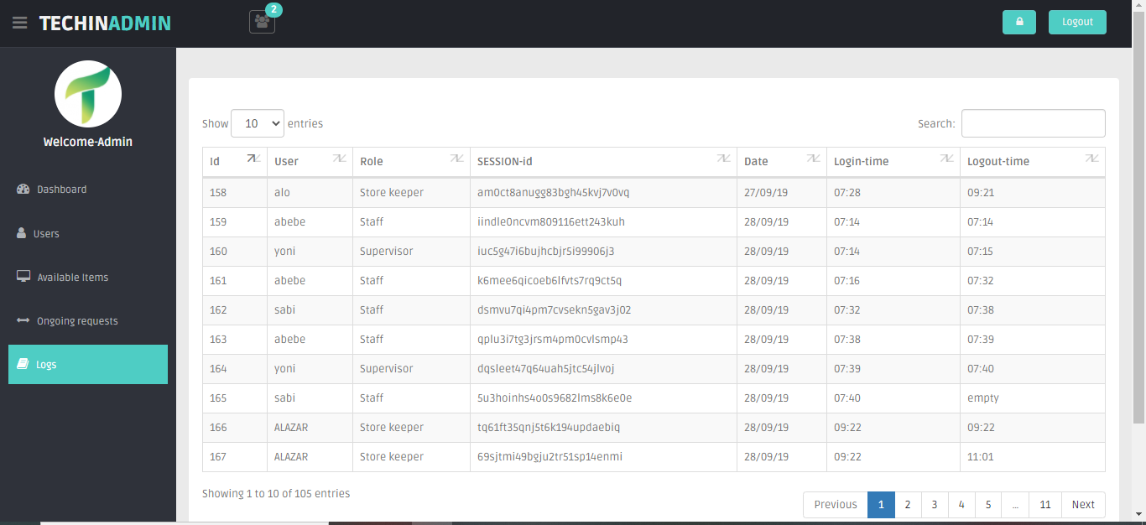

Figure session follow area

### 5.2.2 Store Keeper Account

Among all the roles in the company the store keeper account is the busiest and it’s the role with many tasks in the system.

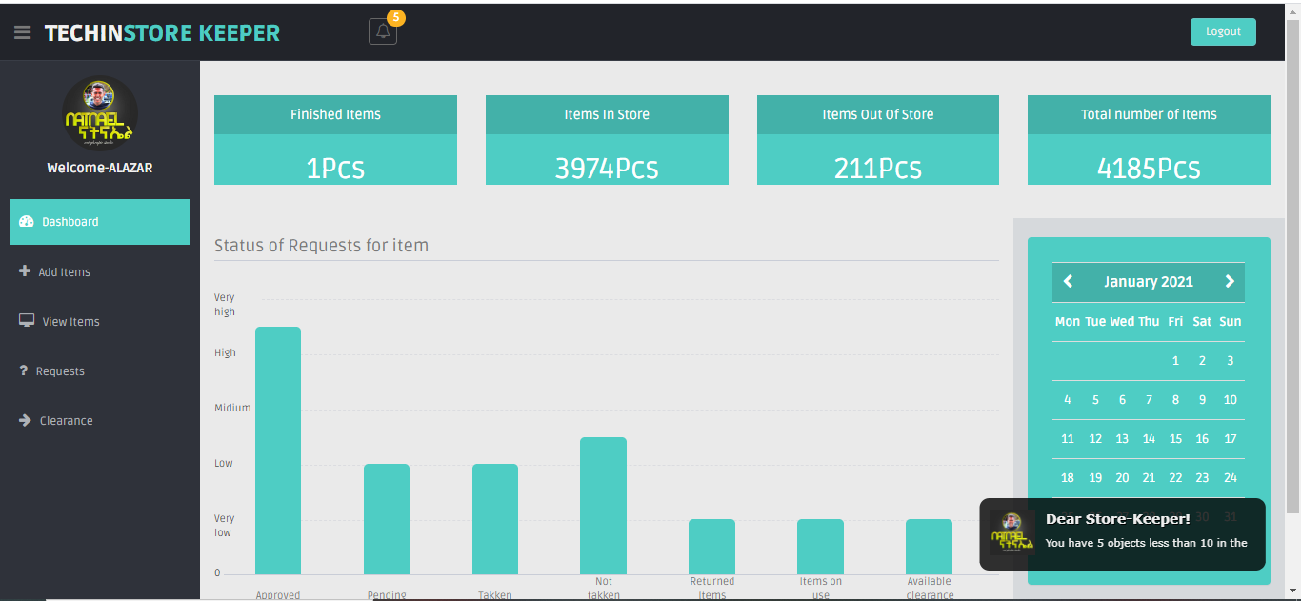

Figure Store keepers’ dashboard

Here in the dashboard every number of items in the category is automatically counted by the system and provided for the dashboard. Additionally, the incoming and outgoing request for items by the staff are displayed by a graph for a better display of what’s going in the system. the calendar additionally advantages the store keeper to keep him/her up to date.

Finally, in the dash board automatically provide the storekeeper a toast notification for implying that some items are coming below the range provided for notifying (in this case 10 in number), so the system automatically notifies for reminding the procedure of procurement.

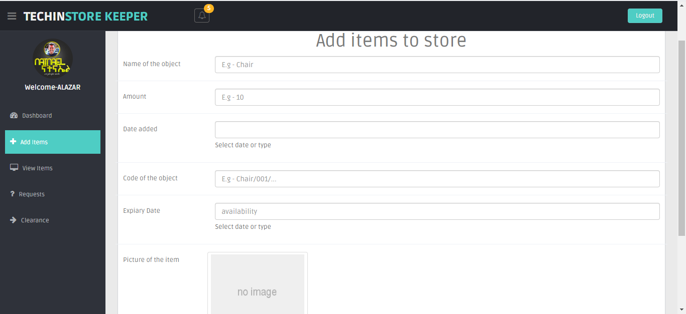

Figure raw material adding form

Item (raw material) adding can be held by filling the form above in the above figure including the picture o it for a better browsing.

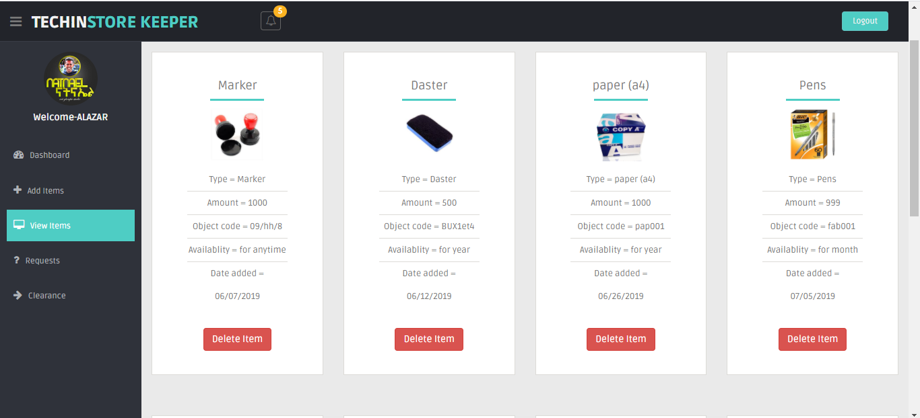

Figure added materials

The store keeper can then delete the added items or modify the information’s inserted along with the specific item or raw material.

This feature is only visible for the store keeper, others can not do this but they simply can browse through and request for taking the desired item.

The items added are also available for searching, the system has got a search feature that helps to find items desired out of the vast data in the system.

The next main feature is system users request handling feature. This I can say is the main purpose of the store keeper. It has a lot of features inside to manage the requests of the users (supervisors and operators). The store keeper gives the item requested for the operator who requests only if the manager or supervisor allowed it on the system.

And again, the one who requests it have to confirm it in their own account as a digital signature, for confirmation of taking the raw material.

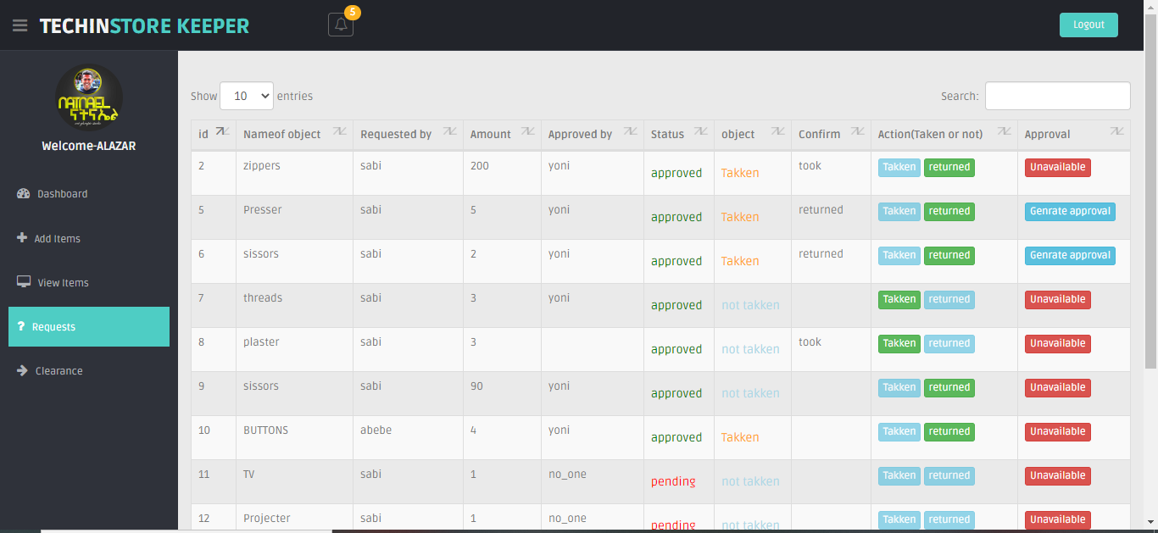

Figure request handling feature

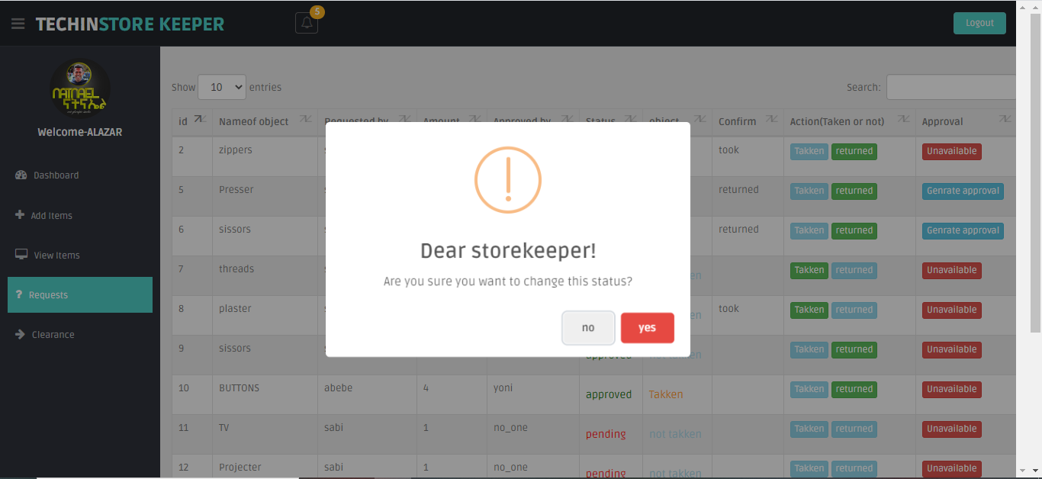

Figure status change

The status can be changed to either taken or not taken according to the approval’s status, and the change in main approval to take the item from the store.

Clearance is the next feature if the operator or supervisor leaves the company, they can return the items that cannot be finished (items like computers) and generate a clearance for it.

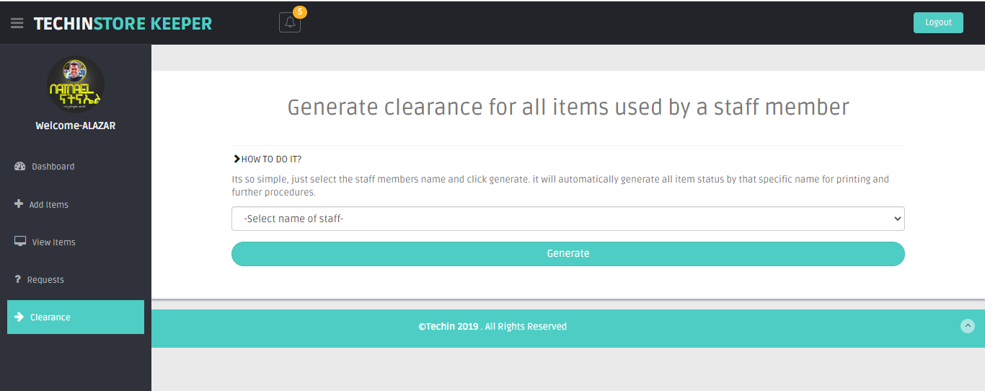

Figure clearance features

The store keeper selects one of the users and generates a clearance as a pdf with all the history of the user regarding all the items and raw materials the staff has took and returned.

### 5.2.3 Production managers Account

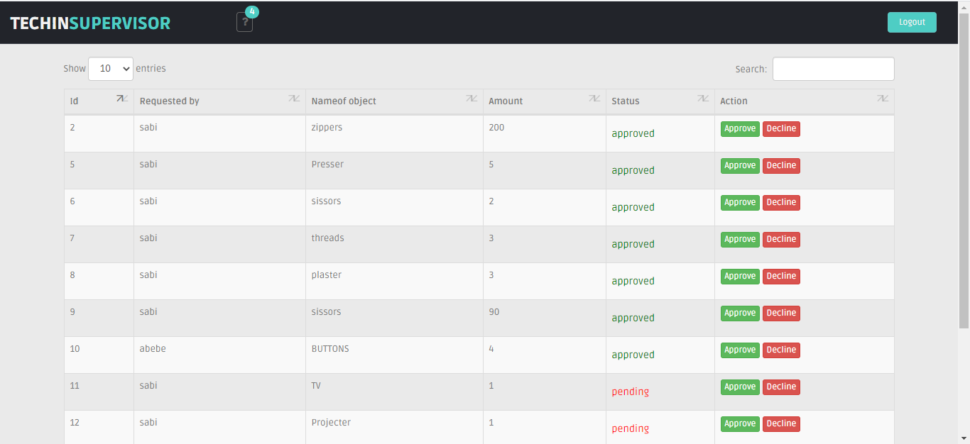

Figure Production managers view

The only task of a super visor is to approve or deny a request that I sent by the assigned operators or section supervisors. This role is also provided by a notification to notice that there are new requests.

### 5.2.4 Staff Account

Here the staff or operators and supervisors can browse through out the data in the system, and requests a raw material for production.

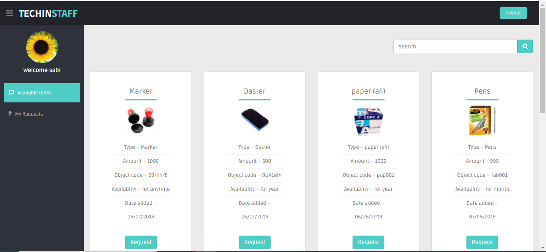

Figure staffs view of browsing raw materials

While requesting an item the operator is required to input the right amount and its allowed only to ask in the right range only. If below or above the amount in stock the system automatically blocks the request.

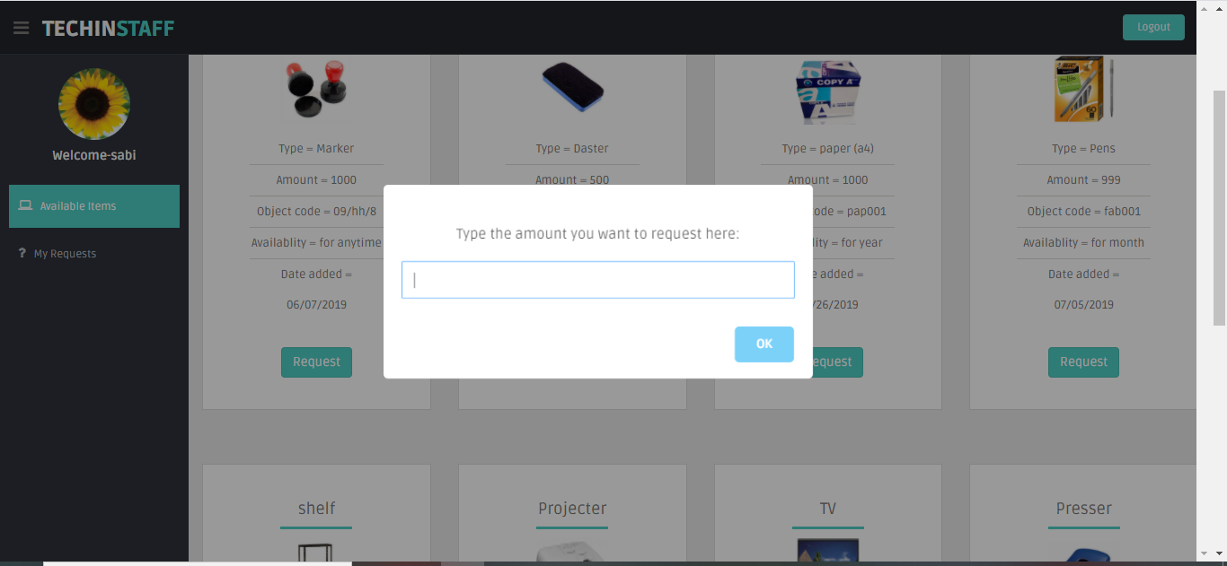

Figure amount insertion

The next and final feature is to track once own record of request if allowed and denied. Then another features like confirming for taking the requested item is also a part of the features in the staff role.

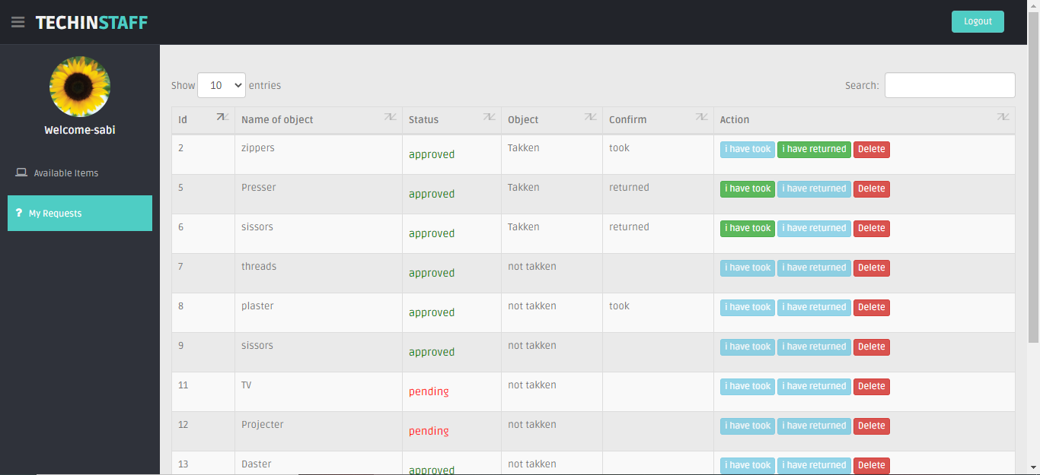

Figure request tracking

## 5.3. Cost benefit analysis

In terms of cost this system has two benefits. The first thing is that as me being an intern in the company I provided the system for free. This system is expected to be sold by up to 500,000 ETB for other private companies and the company saves this amount of money. And by deploying this system and using it save a significant amount of time for the company and it benefits more working hours which can be converted into many products and it will be turned out into money after all.

### B. The solution for design room work handling

The design and product development section in Ramsey company needs change of shelfs for displaying and handling the prototypes developed in a dust protective shelf and with enough light system for blowing out the view of the prototype shoe like the one I mentioned in the following figure.

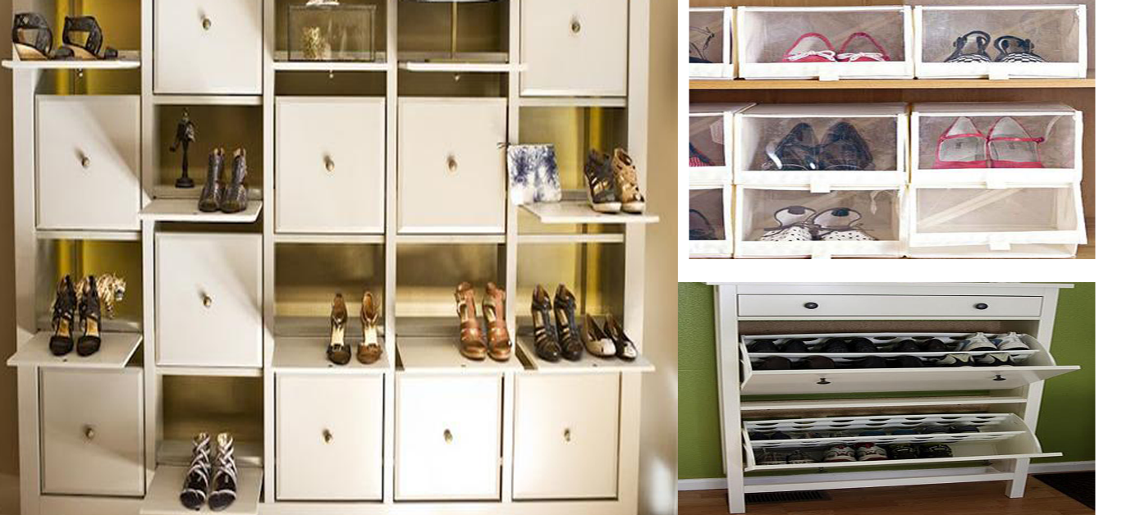

Figure preferred shelf for design room

The other factors observed as a problem was the tables and chairs used in the design section were not very comfortable for work and needs to be changed.

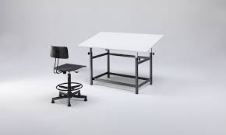

Figure design chair and table

The tables need to incline in some degree for comfort while designing and the chairs have to be resizable in terms of height for customizing the height while design and they need to support the back of the designer.

Other than the major changes needed additional factors also have to be provided for creating better design environment such as

* Air conditioning
* Hot drink machines (coffee and tea)
* Water dispensing machine
* Good Wall paint
* And other additional things for making the design environment better

# 6. Recommendation, implication and conclusion